***Steps to New Connection to PDOA Database through Toad.***

***Step 1:***  Open TOAD from your desktop and click File🡪New🡪Connection

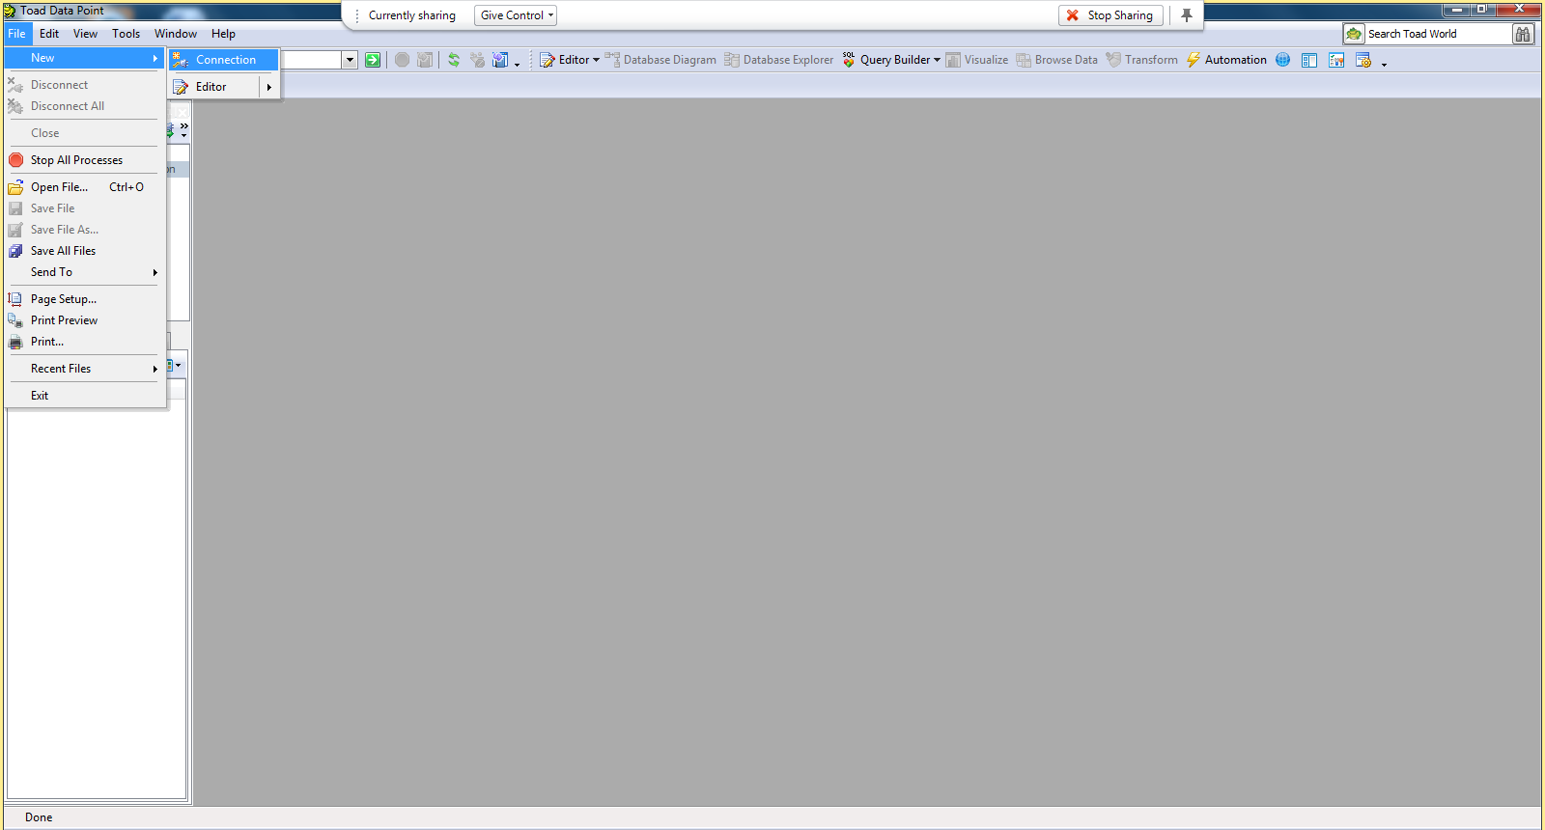

‘

***Step 2:***  Select IBM DB2 LUW under the “Group” drop down

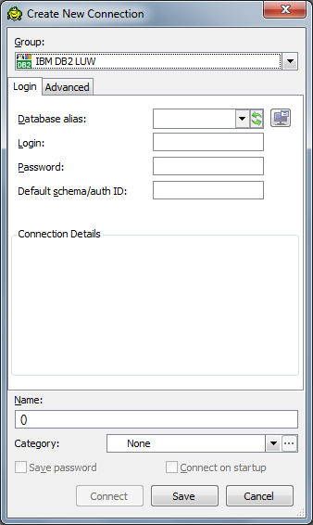

***Step 3:***  Launch the DB2 Client Configuration Wizard ( ie the right box besides the Database Alias drop down) 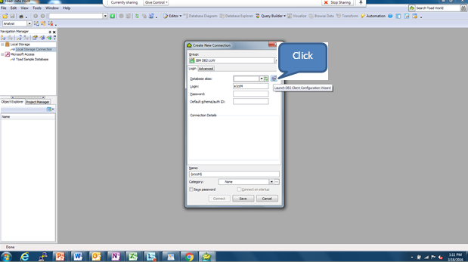

***Step 4:***  Click Add Catalog Entry

***NOTE : If you already have the connection to BI Appliance using the same configuration, please remove the catalog entry before proceeding ahead or edit the catalog entry.***

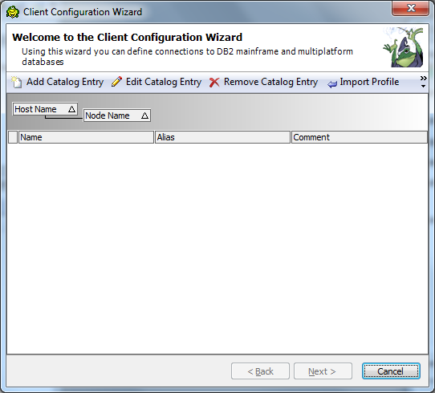

***Step 5:***  Select AIX under operating System.Enter the following Hostnames :

|  |  |  |
| --- | --- | --- |
| Environment | Host Name | Port Number |
| Dev | bidb-dev.suntrust.com | 50000 |
| QA | bidb-qa.suntrust.com | 50000 |
| Prod | bidb.suntrust.com | 50000 |

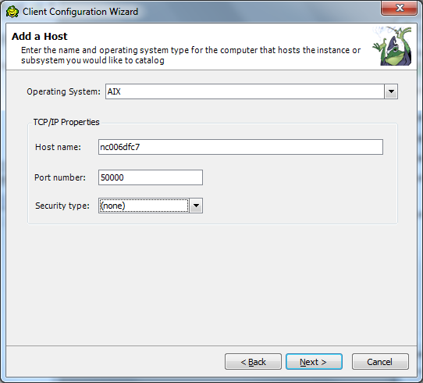

***Step 6:***  Specify the following instances :

|  |  |  |
| --- | --- | --- |
| Environment | Node Name | Instance Name |
| Dev | PDOA_DEV | ddv01cdw |
| QA | PDOQ_QA | dqa01cdw |
| Prod | PDOA_PROD | dpd01cdw |

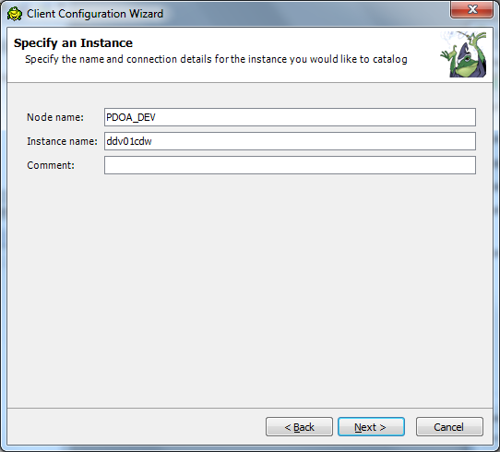

***Step 7:***  Click next and enter the following information :

|  |  |  |  |
| --- | --- | --- | --- |
| Environment | Database Name | Database Alias | Authentication |
| Dev | ddv01cdw | ddv01cdw | Server encrypt |
| QA | dqa01cdw | dqa01cdw | Server encrypt |
| Prod | dpd01cdw | dpd01cdw | Server encrypt |

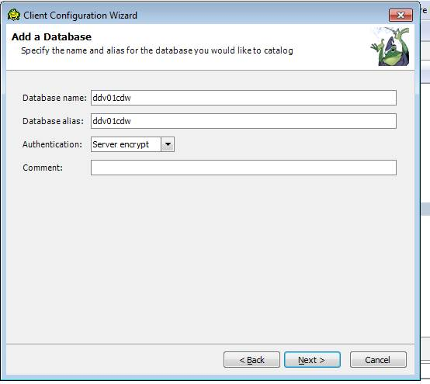

***Step 8:***  Click Finish:

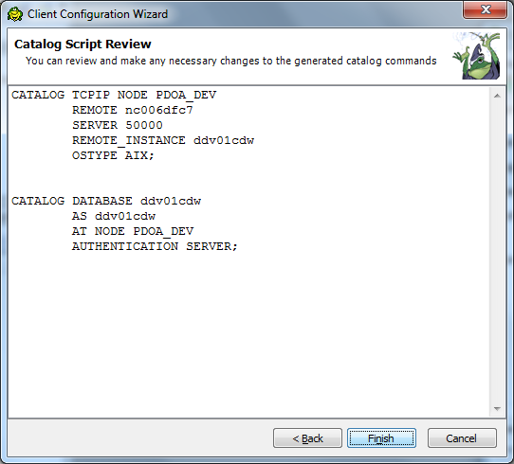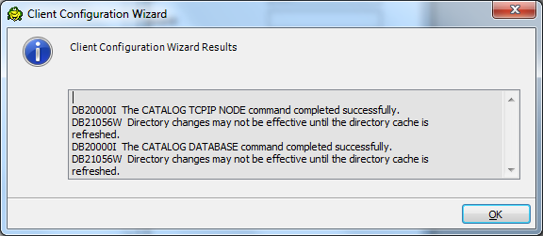

***Step 9:***  Enter your login (RACF ID) and **Windows** Password to login:

